Exercise: Android Overview and Basic
Document Number: |  | Issue Number:  Date:

TABLE OF CONTENTS
1 Exercise 1: Install needed softwares 2
1.1 Description 2
1.2 Install Java 2
1.3 Install Android Development Kit 2
1.4 Install Eclipse 3
1.5 Install ADT 3
2 Exercise 2: Working with Android Device Manager and DDMS 5
2.1 Exercise 1: Create a virtual machine 5
2.2 Send a Message use DDMS to our Virtual Machine. 8
3 Create a first Android project 12
3.1 Create Android application 12

Exercise 1: Install needed softwares

Description
The purpose of this exercise is make students get familiar with the environment of Android software development. At the end of this exercise, student know and can use those tools:
Eclipse + ADT plugin
Android SDK Tools
Android Platform tools
Android API mới nhất
Android system image mới nhất cho Emulator

Install Java
Go to <<SOFTWARE>> and download JDK. Install it at C:\Java\jdk1.7.x

Install Android Development Kit
Go to <<SOFTWARE>>. Choose Android SDK. Copy it to d:\Android\android-sdk.
Start SDK Manager.
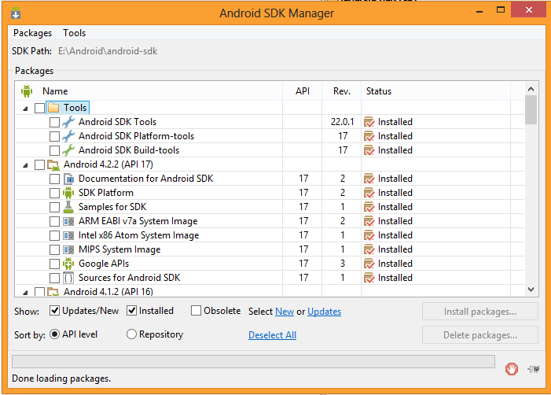

Install Eclipse
Go to <<SOFTWARE>>. Copy eclipse to D:\Eclipse. Start Eclipse
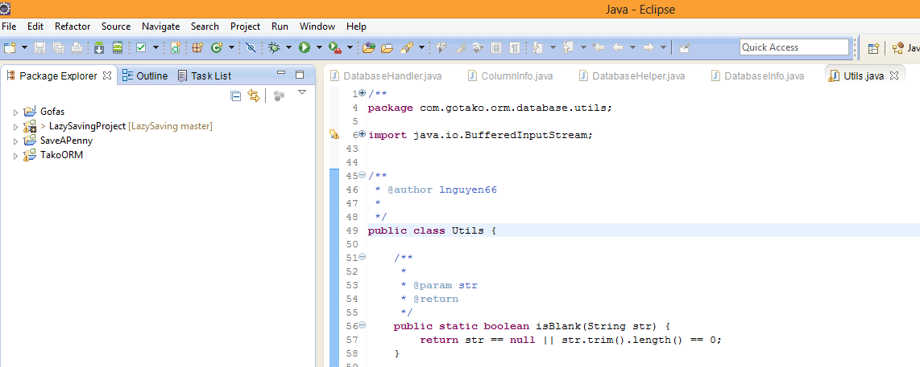

Install ADT
Go to Help -> Install New Software
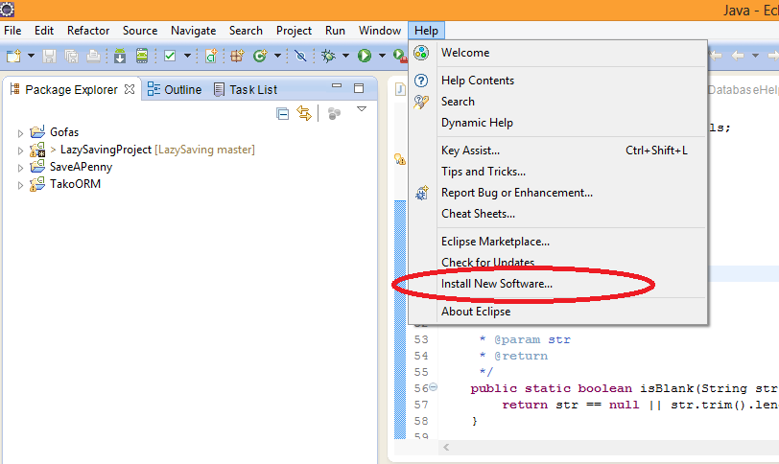
Press Add
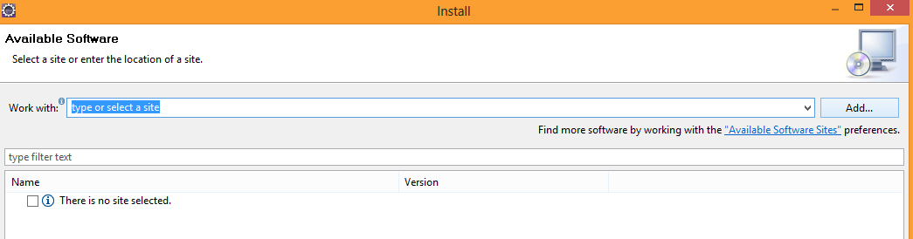
Type those things:
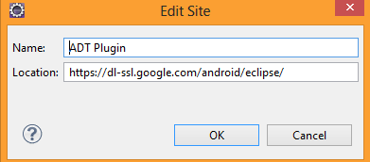
Location: https://dl-ssl.google.com/android/eclipse/
Name: ADT Plugin

Press OK.
Choose all when updating
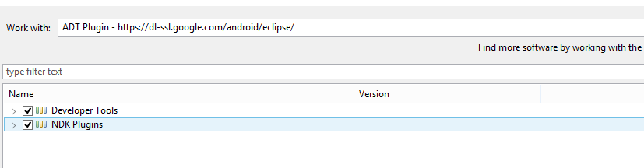

Restart Eclipse.
Go to Windows -> Preferences -> Android set the SDK location to the installed one.
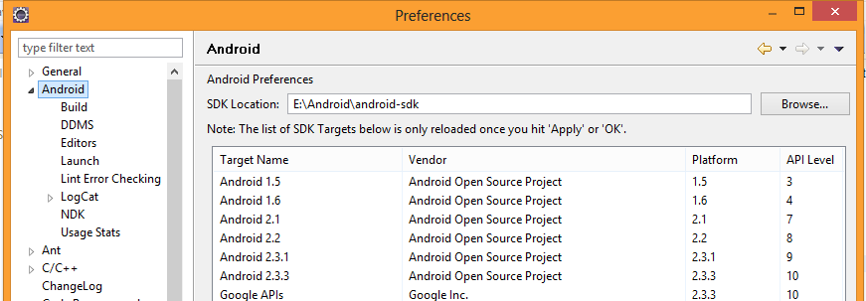
Congratulation ! You have completed install Android SDK and Android ADT for Eclipse.

Exercise 2: Working with Android Device Manager and DDMS

Exercise 1: Create a virtual machine
- Open Android Virtual Device Manager in 1 of 2 ways below:
- In Eclipse: Go to Windows - > Android Virtual Device Manager
Go to d:\Android\android-sdk - > Run AVD Manager.bat
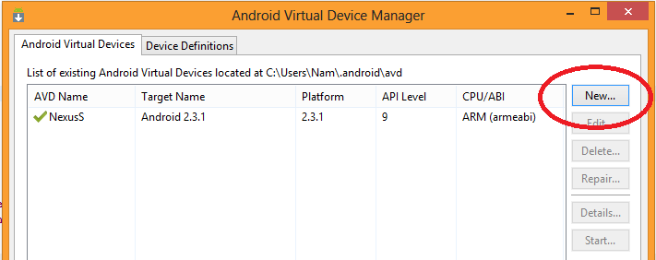

Press New.
Populate options as below:
AVD Name: Android4.2 without space.
Device: Nexus S
SD Card size : 10.
Other options are populated automatically when you choose Nexus S.
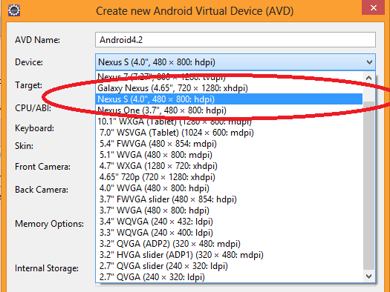
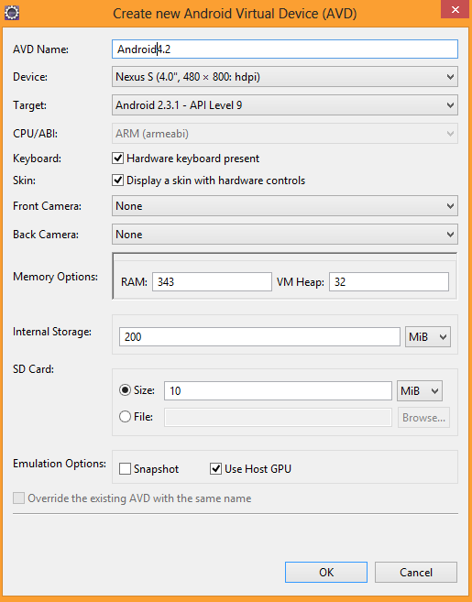

Press OK.

Choose it and press Start.
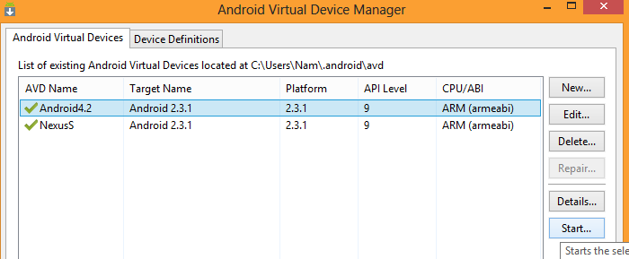
Press Launch. Wait until virtual machine start completely.
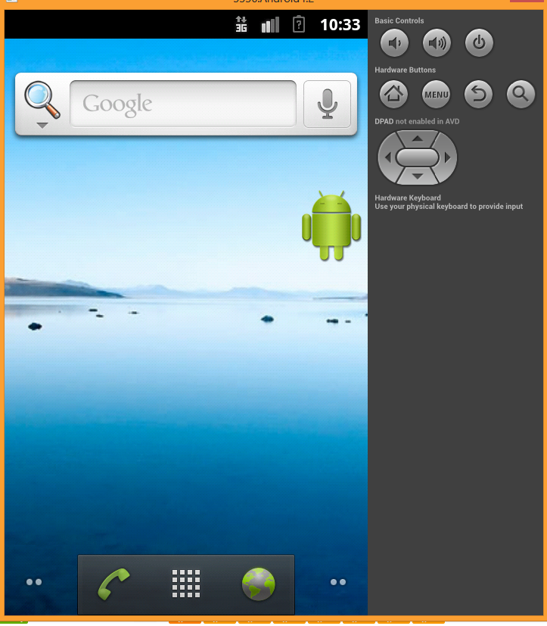
Take note to the port:
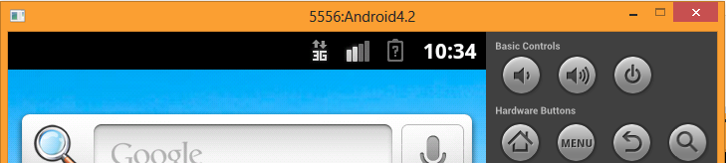

Send a Message use DDMS to our Virtual Machine.
Go to Windows -> Show View -> Others -> Log Cat
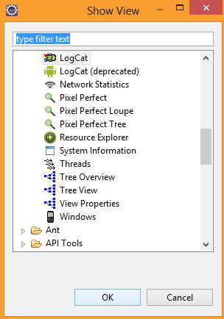
Watch it. When your application run on Virtual Machine it will show debug information and error when our application has error.
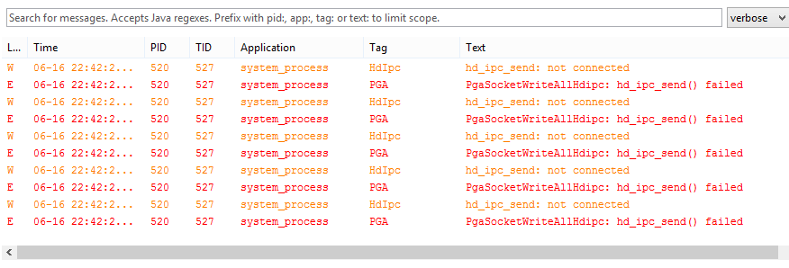

Go back to Virtual Machine.
Press Ctrl F11 to change it to horizontal view. Press Control + F11 to turn it back.
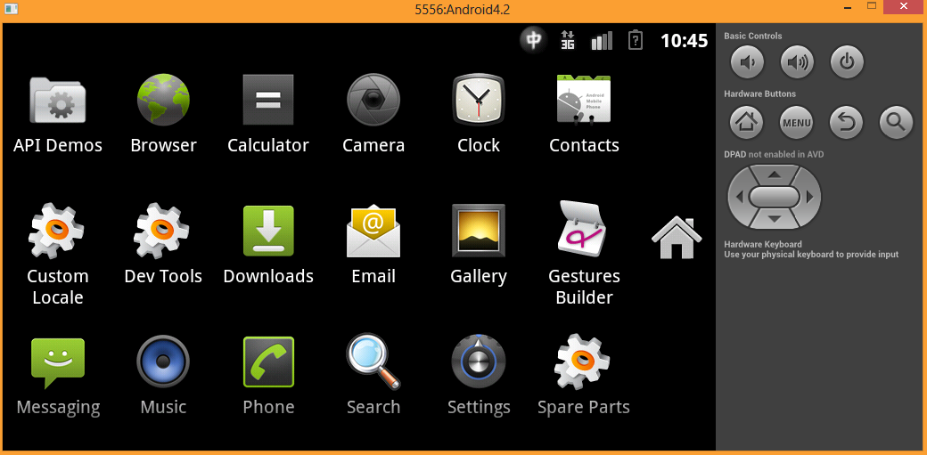
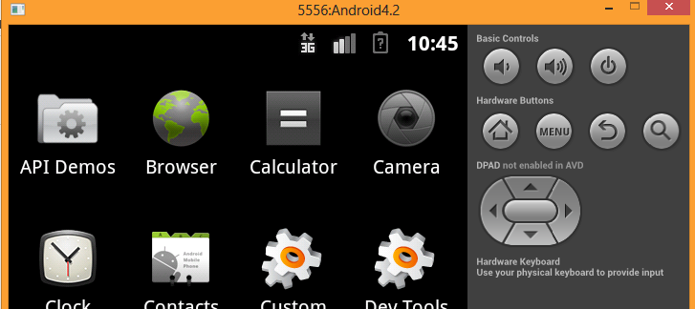

Go back to Eclipse.
Go to Windows ->Open Perpecstive -> DDMS
Choose Android4.2
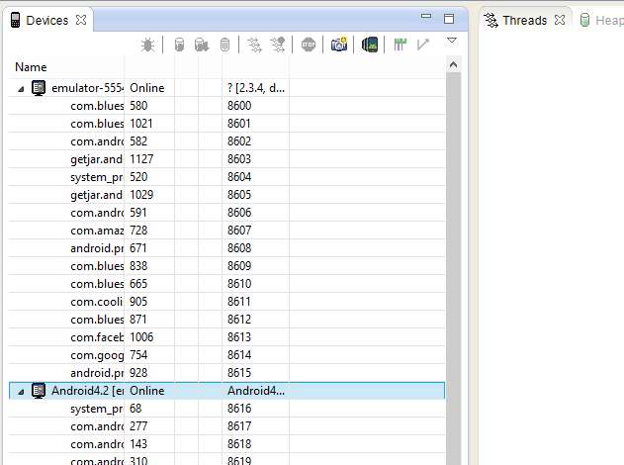
Choose Emulator Control in right tabs.
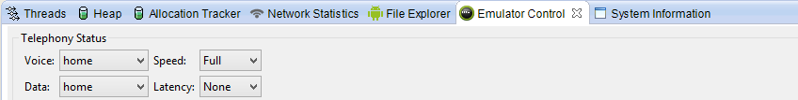
Type number and Message as below:
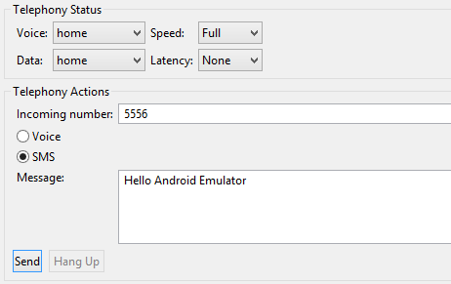
Press Send. Go back to Virtual Machine

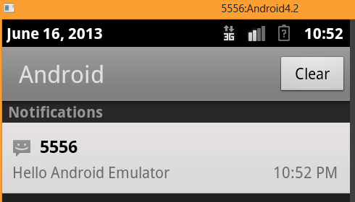

The message shows on notification bar.
In Eclipse -> Go to tab File Explorer
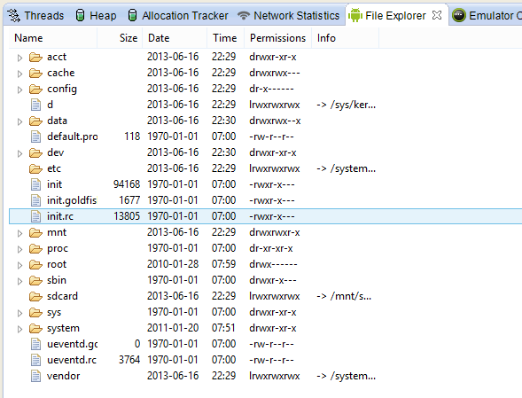

Copy a file to mnt/sdcard
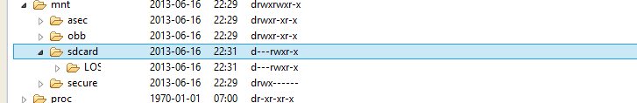
This is the way you access sdcard of a Virtual Machine.
Congratulation! You have completed Exercise 2.

Create a first Android project

Create Android application
In Eclipse, go to File -> New -> Other
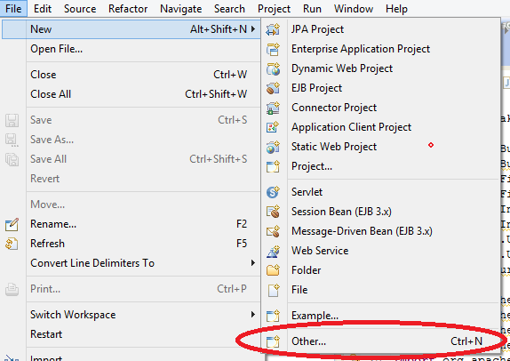
Choose Android -> Android Application Project
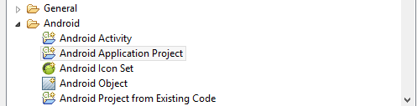
Name it: My First App. Watch other options are auto-filled. Click Next.
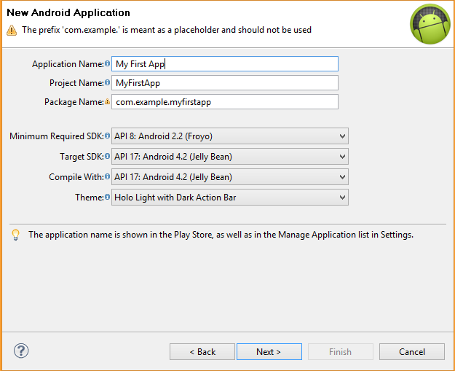
Click Next.
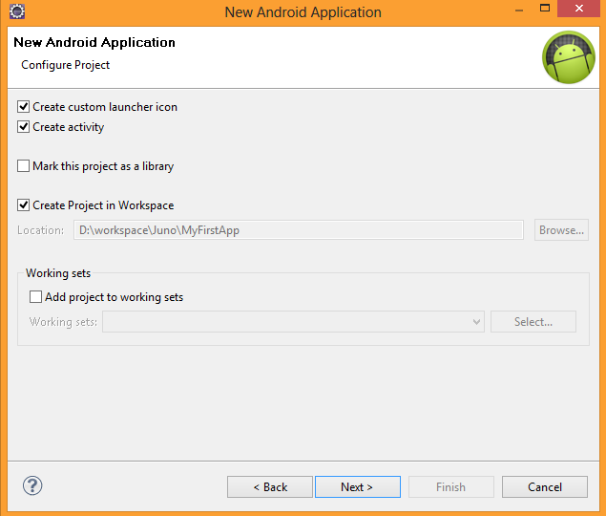
Click Next until you see Finish is highlighted.
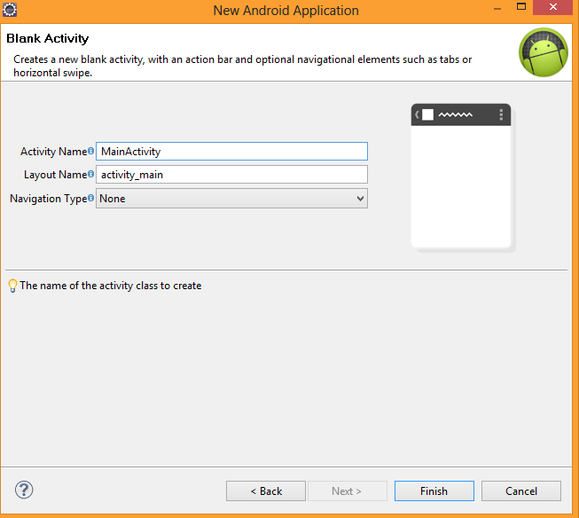
Click Finish.
It shows the main screen in design mode.
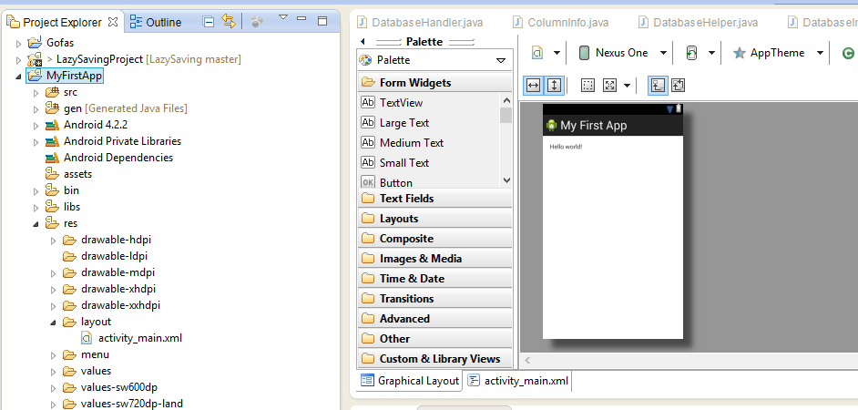
Now we will run our application on Android virtual machine.
Right click on MyFirstApp, choose Run As → Application
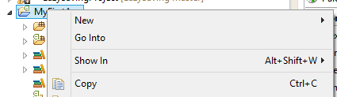
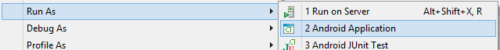
Choose Android4.12 and press OK.
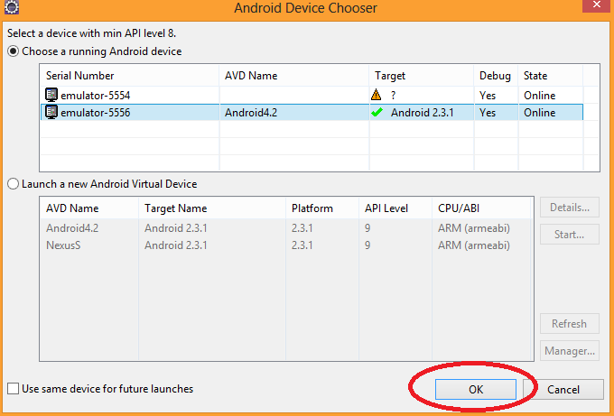
Back to our virtual machine and wait.
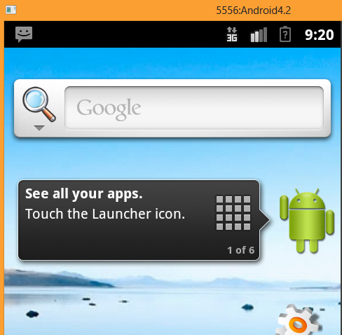

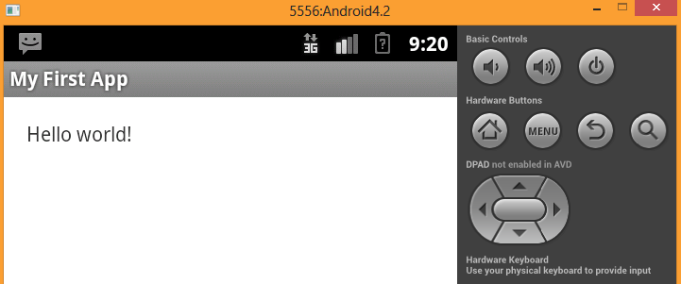
Congratulation! You have completed creating and running the first Android application.

